336 Final Project Documentation

User Story

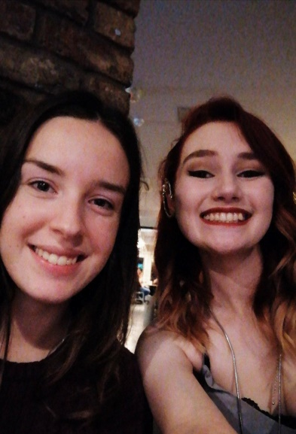

This is Emily and Mo, they are co-heads of live music society at the University of Stirling. They want a website for the society which has many features like an image gallery, an interactive calendar and a room booking system. The website should have a login page for members as only members should be allowed to book a practice room. The calendar should show events of the society and you should be able to change the month to show the events for future ad previous months. The website

Mockups

Events Page

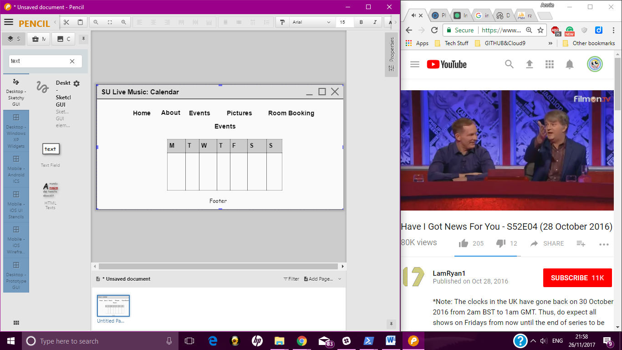

Login Page

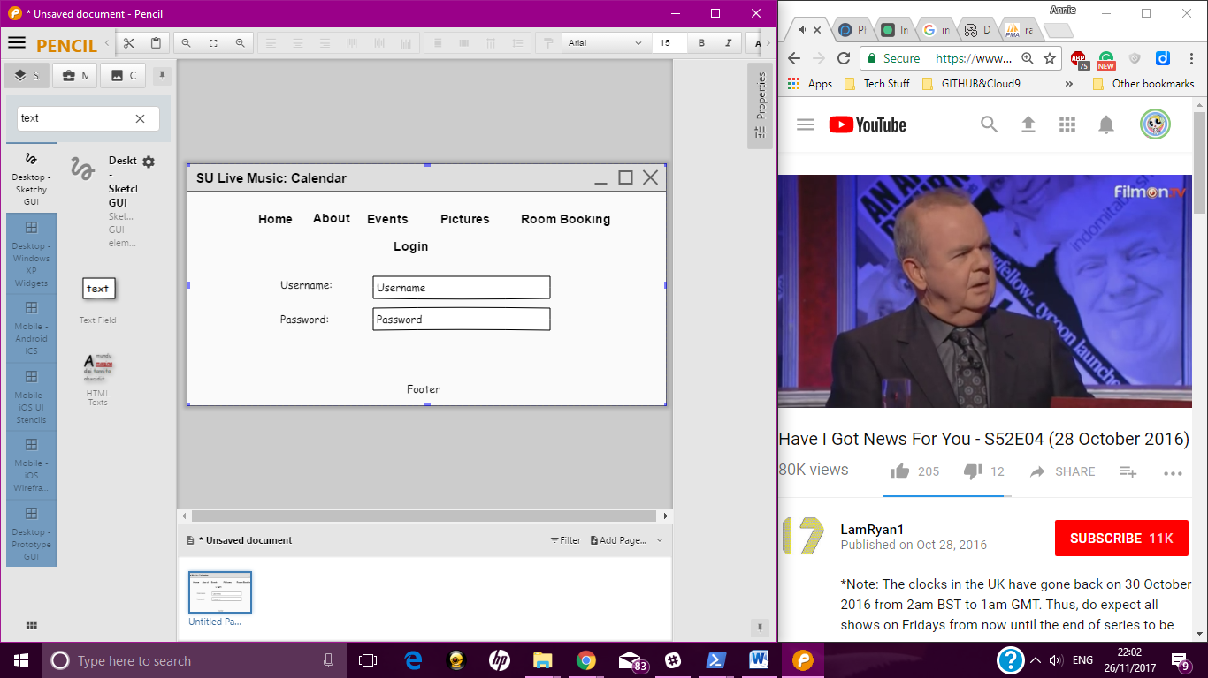

Room Booking Page

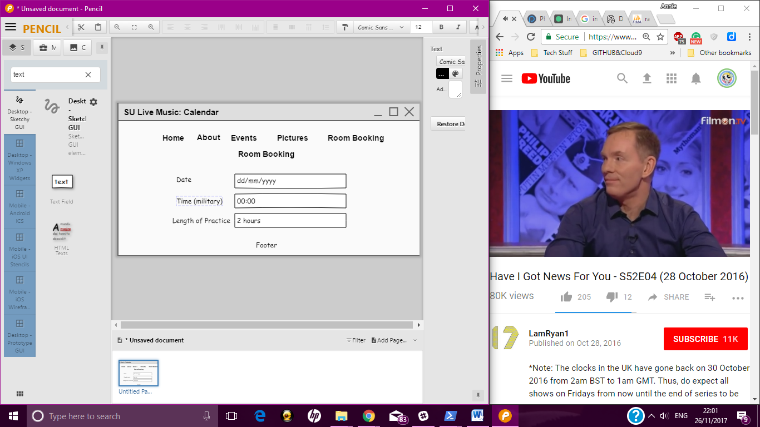

ER-Diagrams

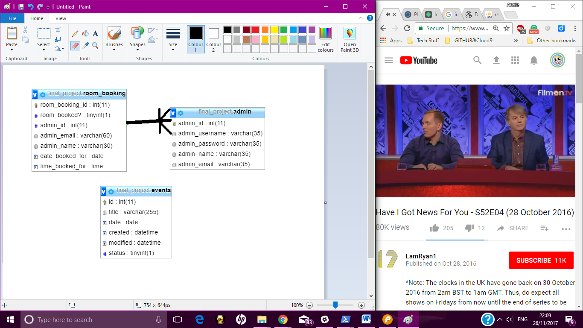

Screenshots

